

**Module Code & Module Title**

**CS6P05NI Final Year Project**

**Assessment Weightage & Type**

**25% FYP Interim Report**

**Semester**

**2020 Autumn**

**Student Name: Sagar Poudel**

**London Met ID: 18030043**

**College ID: np01cp4a180204**

**Internal Supervisor: Pritivi Maharjan**

**External Supervisor: Shubhankar Sharma**

**Assignment Due Date: 2020/12/25**

**Assignment Submission Date:2020/12/25**

**Word Count (Where Required):**

*I confirm that I understand my coursework needs to be submitted online via Google Classroom under the relevant module page before the deadline in order for my assignment to be accepted and marked. I am fully aware that late submissions will be treated as non-submission and a mark of zero will be awarded.*

**Acknowledgement**

This interim report would not have completed successfully without encouragement and guidance of my supervisors Mr. Shubhankar Sharma and Mr. Prithivi Maharjan. I always feel encouraged and motivated after attending meeting with them. I am grateful for their guidance, support, supervision and encouragement. I would like to extend my sincere thanks to both of supervisors for their tremendous help and support. I would also like to thank my friends and the participants in my survey, who have voluntarily shared their valuable time for goodwill of this report.

**Abstract**

This report is like progress report of final year project **Institute Management System** which is a web-based application. This application is helpful for educational institute to maintain record of their students, send SMS to students regarding class, overview flow of students in institute via various reports. This application also includes Point of Sales system so that institute can sell study related books.

This report consists details regarding progress of final year report in the means of five chapters such as Introduction, Background/literature review, Development to Date, Analysis of Progress and Future Work.

Introduction includes short information of final year project i.e. **Institute Management System** whereas background/literature review holds detailed information about resources requirements , methodology used in developing project along with analysis and comparison of similar projects. Detailed information of development of project till date, progress analysis by comparing with Gantt chart and work that is to be done further are provided respectively in development to date, analysis of progress and future work section.

Table of Contents

1. Introduction 1

1.1. Problem statement 1

1.1. Project as a solution 1

1.2. Aim and Objectives 2

1.2.1. Aim 2

1.2.2. Objectives 2

1.3. Report Structure 2

2. Background/literature view 3

2.1. Client Description and Requirements 3

2.1.1. Client’s Name 3

2.1.2. Description 3

2.1.3. Requirements 3

2.2. Resource requirements 4

2.2.1. Software Requirements 4

2.2.2. Hardware Requirements 4

2.3. Methodology 4

2.3.1. Considered Methodology 4

2.3.2. Selected Methodology 5

2.4. Similar Projects 6

2.4.1. Project 1 : Web Based Student Information Management System 6

2.4.2. Project 2: Student Record Management System 7

2.4.3. Project 3: Student Management System 8

2.5. Analysis of similar projects with my projects 9

3. Development to date 10

3.1. System architecture 10

3.2. Use case diagram 11

3.3. High level use case descriptions 11

3.4. Wireframes 16

3.5. ER diagram 25

3.6. Web application development 26

3.6.1. Staff Login Page 26

3.6.2. Admin Login Page 26

3.7. Gantt Chart 27

4. Analysis of progress 29

4.1. Progress table 29

4.2. Progress Review and Action Plan 29

5. Future work 30

6. References 31

7. Appendix A 32

8. Appendix B 33

9. Appendix C 34

Table of Figures

Figure 1 Web Based Student Information Management system 6

Figure 2 Student Record Management System 7

Figure 3 Student Management System 8

Figure 4 System Architecture 10

Figure 5 Use case diagram of Institute Management System 11

Figure 6 Admin Panel Login Page 16

Figure 7 Login for Staff Page 17

Figure 8 Point of sales / landing page of web application 18

Figure 9 Student Registration page 19

Figure 10 Send SMS page 20

Figure 11 Student Details Page 21

Figure 12 Account Setting / Staff Setting page 22

Figure 13 Admin Setting Page 23

Figure 14 Report Page 24

Figure 15 ER Diagram 25

Figure 16 Staff Login Page 26

Figure 17 Admin Login Page 26

Figure 18 Gantt Chart 27

Figure 19 Staff Login Source Code 32

Figure 20 Admin Login Source Code 33

Figure 21 Survey Question 1 34

Figure 22 Survey Question 2 35

Figure 23 Survey Question 3 35

Figure 24 Survey Question 4 36

Figure 25 Survey Question 5 36

Figure 26 Survey Question 6 37

Figure 27 Survey Question 7 39

Figure 28 Survey Question 8 39

Table of tables

Table 1 Project Comparison Table 9

Table 2 High level use care description of login 11

Table 3 High level Use case description of register student 12

Table 4 High level Use case description of send SMS 12

Table 5 High level Use case description of fee payment 12

Table 6 High level Use case description of view student details 13

Table 7 High level Use case description of update profile 13

Table 8High level Use case description of register book 13

Table 9 High level Use case description of make sales payment 14

Table 10 High level Use case description of login admin 14

Table 11 High level Use case description of set fee 14

Table 12 High level Use case description of register staff 15

Table 13 High level Use case description of view/print report 15

Table 14 High level Use case description of update admin password 15

Table 15 Gantt chart 28

Table 16 Progress Table 29

**Institute Management System**

# Introduction

This system is a web application for educational institute specially for those institute which provides education to various types of students. As being a developing country, education system is also in the phase of development so that most of works are manually done in the field of education. There are various sources that provide education such as school, college, institute. This project is focused on educational institute that provides education to people who get enrolled to compete in exams of government jobs/ public service.

## Problem statement

In educational institute, there are many students and their records are almost manual in most of education system. Educational institute have problem due to:

1. Manual record of students
2. Depend on paper / register/ brain to remember type of student
3. No proper track of students
4. Difficulty in sending SMS to students
5. Manual billing of fee payment

## Project as a solution

This project will help people who will have educational institute by working as solution:

1. Digital record of students
2. Allocates students at the time of admission
3. Sending SMS to students to give information about class
4. Digital billing of fees
5. Generate manual/month/annual report
6. Digital billing of books related to study materials by using barcode.

## Aim and Objectives

### Aim

The main aim of project to make work digitalize more than manual in the field of educational institute.

### Objectives

Some objectives of project are:

* To learn about scope of digitalization
* To manage manual works of institute.
* To learn about API programming.
* To make work easier for people involving in educational institute
* To get knowledge on programming concept

## Report Structure

This part of report shows structure of remaining parts.

1. Background/ literature view
2. Client Description and Requirements.
3. Resource Requirements
4. Methodology Used
5. Similar Projects
6. Analysis of similar projects with my projects
7. Development to date
8. System Architecture
9. Use case diagram
10. High level use case descriptions
11. Wireframes
12. ER diagram
13. Web application development
14. Analysis of progress
15. Future work
16. References
17. Appendix A
18. Appendix B
19. Appendix C

# Background/literature view

## Client Description and Requirements

### Client’s Name

The Success Institute

### Description

This institute is newly, fresh startup which gives tuition classes for courses such as staff nurse, A.N.M, AHW, *kharidar*, *nayab* *subba* etc. Our client “The Success Institute” is located in Nepalgunj, Banke. Founders of this institute are young and energetic so they were eager to listen about project IMS and assured to give essential requirements which can be helpful in making a good project.

### Requirements

Requirements and suggestions provided by client are given below:

1. System should be secure enough so that no outsider can interfere or stalk on confidential data of institute.
2. System must have different login system for both staff and owner so that staff couldn’t misuse system.
3. There is difficulty in sending message to every student so that system should have feature of sending SMS to student at once.
4. System should be able to show/ track reports monthly/annually.
5. There should be feature of viewing and printing reports of fee.

*Please refer* *Appendix C* *for Survey Findings*

## Resource requirements

### Software Requirements

* PHP/ Laravel Framework
* MySQL for Database
* Html/CSS/JS
* Code editor i.e. Visual Studio / PHP storm
* API for SMS integration.
* Bar code reader app if scanner is not available

### Hardware Requirements

* PC with windows 10
* Web cam/ phone with camera/ bar code scanner for scanning bar code of books.

## Methodology

### Considered Methodology

Waterfall Methodology

Waterfall methodology is also one of the methodologies which is commonly used at the time of software development. It is a sequential development model. Different phases of waterfall model life cycle are:

i) Analysis

ii) Design

iii) Development

iv) Testing

v) Implementing

vi) Maintenance

In this methodology, all phases are carried out in a linear sequence i.e. to go to next phase previous phase must be complete. All phases are done without overlapping to one another. Each step is frozen before initialization of next step. Requirement phases should be frozen before starting design and for coding phase design phase should be completed.

This method was not selected because of its linear sequence. As this project is web application and as design part and other logical part are always iterative model need to be flexible and support changes in any part of phases in order to catch up with modern days. In this project, requirement can be changed as per guidance and requirement of client and this changing in requirement is not supported by waterfall methodology. (S.Balaji & Murugaiyan, 2012)

### Selected Methodology

Rational Unified Process

There are many methodologies for software development. Some of them are; waterfall, agile, scrum, spiral, joint application, rational unified process etc. We are using Rational Unified Process (RUP) for development of this project.

Rational Unified Process (RUP) is one of the techniques used for software development. RUP provides a disciplined approach to assigning tasks and responsibility within a development organization. Its main goal is to ensure the production of high- quality software that meet the need of end-users within a predictable schedule and budget. (Kruchten, 2004) There are four phases of RUP methodology. They are:

* Inception:

In this phase, requirement analysis is done. This is the phase which describes schedule, estimation of overall system and risk assessment of project. It also describes scope and goals of the system along with identifying interaction with systems (t4tutorials, 2020).

* Elaboration:

Architecture of system is evaluated in this phase of rational unified process. This phase is considered important as it includes analysis of problem domain. Use case diagrams are made in this phase (Christensson, 2006).

* Construction:

In this phase, major coding is done along with extensive testing. In big projects, construction phase can be repeated or there may be several constructions phases in order to divide use cases into segments so that it will be smaller and manageable. At the end of this stage, the project team should have user manuals and a beta version of the system ready to be evaluated. (ANWAR, 2014)

* Transition:

Transition is the last phase of rational unified process in which analysis of system along with its maintenance is done. This is the phase where product is released. (Scott, 2001) .

## Similar Projects

### Project 1 : Web Based Student Information Management System

Authors: S.R.Bharamagoudar , Geeta R.B. , S.G.Totad

This Student Information Management System helps in maintenance of student information. This system can be used by educational institutes to maintain records of students. Student information system deals with all kind of student details, academic related reports, college details, course details, curriculum, batch details, placement details and other resource related details too. User interface of this system is designed and implemented to replace current paper records. The main purpose of this system is to maintain information of students up to date so that it can help in improvement of efficiency of institutes/colleges. (S.R.Bharamagoudar, et al., 2013)

Figure 1 Web Based Student Information Management system

### Project 2: Student Record Management System

Author : Fabian Ros

This Student Record Management System is PHP based system which is made in order to maintain records of students. This project run on virtual serve i.e. XAMPP. This system allows user to add student records such as name, contact number, photo etc. In this system, admin plays vital role by updating, removing students from system. (Ros, 2019)

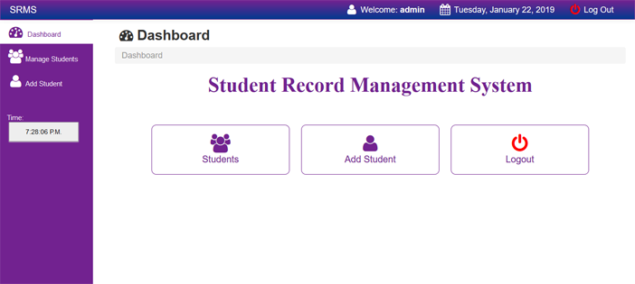

Figure 2 Student Record Management System

### Project 3: Student Management System

Authors: Sangamesh K, Akash Samanekar, Ningappa T Pujar

This Student Management System is a web-based system which will help to manage everyday tasks of institution. The main aim of this project is to manage records of students, attendance , accounts, admissions etc. and keep track of information digitally as many works are carried out of paper based in most of academic institution. (K, et al., 2018)

Figure 3 Student Management System

## Analysis of similar projects with my projects

Project Comparison Table

|  |  |  |  |  |  |
| --- | --- | --- | --- | --- | --- |
| **S.N** | **Features** | **Project 1** | **Project 2** | **Project 3** | **This project** |
| 1 | Technology Used | HTML, CSS, JS, PHP, SQL | PHP, CSS, JavaScript, and Bootstrap. | Java frameworks such as Hibernate, Spring-Data-JPA, Angular | HTML, CSS, JS, PHP/ Laravel Framework, MySQL |
| 2 | Fee Management | ✓ | 🗶 | 🗶 | ✓ |
| 3 | Student Type/ Course Type Management | ✓ | 🗶 | ✓ | ✓ |
| 4 | Easy to use | 🗶 | ✓ | 🗶 | ✓ |
| 5 | SMS sending | 🗶 | 🗶 | ✓ | ✓ |

Table 1 Project Comparison Table

# Development to date

## System architecture

Figure 4 System Architecture

## Use case diagram

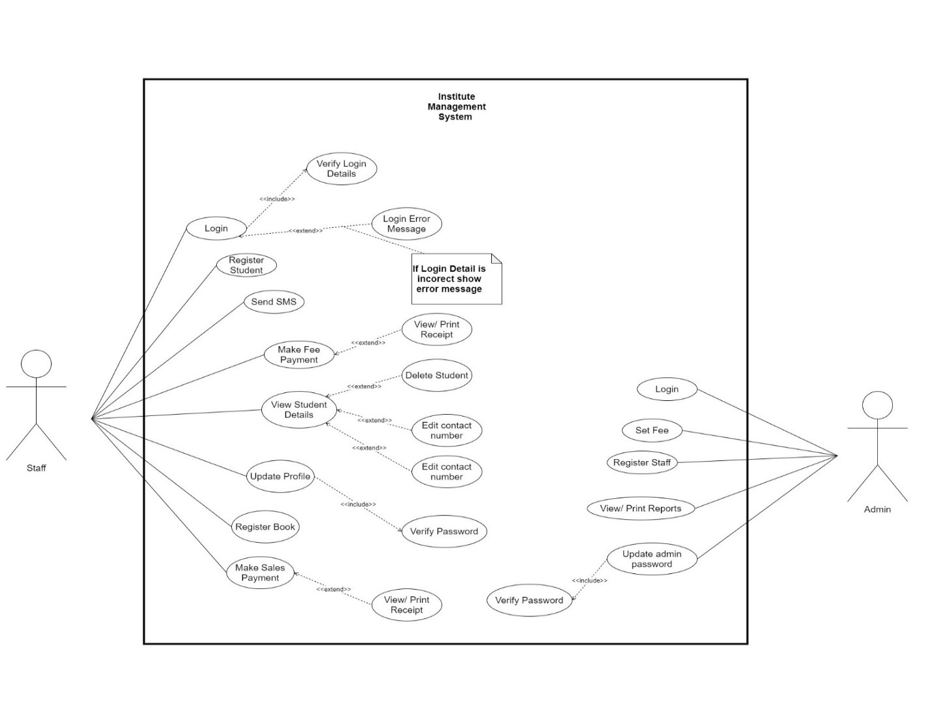

Figure 5 Use case diagram of Institute Management System

## High level use case descriptions

High level use case description are given below:

|  |  |
| --- | --- |
| Use Case | Login |
| Actor | Staff |
| Description | Staff logins to application to access other functions. |

Table 2 High level use care description of login

Table 3 High level Use case description of register student

|  |  |
| --- | --- |
| **Use Case** | **Register student** |
| **Actor** | Staff |
| **Description** | Staff register student in application |

|  |  |
| --- | --- |
| Use Case | Send SMS |
| Actor | Staff |
| Description | Staff send SMS to student choosing from database |

Table 4 High level Use case description of send SMS

|  |  |
| --- | --- |
| Use Case | Fee Payment |
| Actor | Staff |
| Description | Staff makes payment of fee and give receipt to student |

Table 5 High level Use case description of fee payment

|  |  |
| --- | --- |
| Use Case | View Student Details |
| Actor | Staff |
| Description | Staff can view student details along with editing it. |

Table 6 High level Use case description of view student details

|  |  |
| --- | --- |
| Use Case | Update Profile |
| Actor | Staff |
| Description | Staff can update his/her profile |

Table 7 High level Use case description of update profile

|  |  |
| --- | --- |
| Use Case | Register Book |
| Actor | Staff |
| Description | Staff register book that it new to institute . |

Table 8High level Use case description of register book

|  |  |
| --- | --- |
| Use Case | Make Sales Payment |
| Actor | Staff |
| Description | Staff make payment of book that he/she sells. |

Table 9 High level Use case description of make sales payment

|  |  |
| --- | --- |
| Use Case | Login |
| Actor | Admin |
| Description | Admin logins to application to access other functions. |

Table 10 High level Use case description of login admin

|  |  |
| --- | --- |
| Use Case | Set fee |
| Actor | Admin |
| Description | Admin can set fees of various fields that are taught in institute. |

Table 11 High level Use case description of set fee

|  |  |
| --- | --- |
| Use Case | Register Staff |
| Actor | Admin |
| Description | Admin registers staff |

Table 12 High level Use case description of register staff

|  |  |
| --- | --- |
| Use Case | View/ print Reports |
| Actor | Admin |
| Description | Admin can print overall reports. |

Table 13 High level Use case description of view/print report

|  |  |
| --- | --- |
| Use Case | Update Admin Password |
| Actor | Admin |
| Description | Admin update his/her password. |

Table 14 High level Use case description of update admin password

## Wireframes

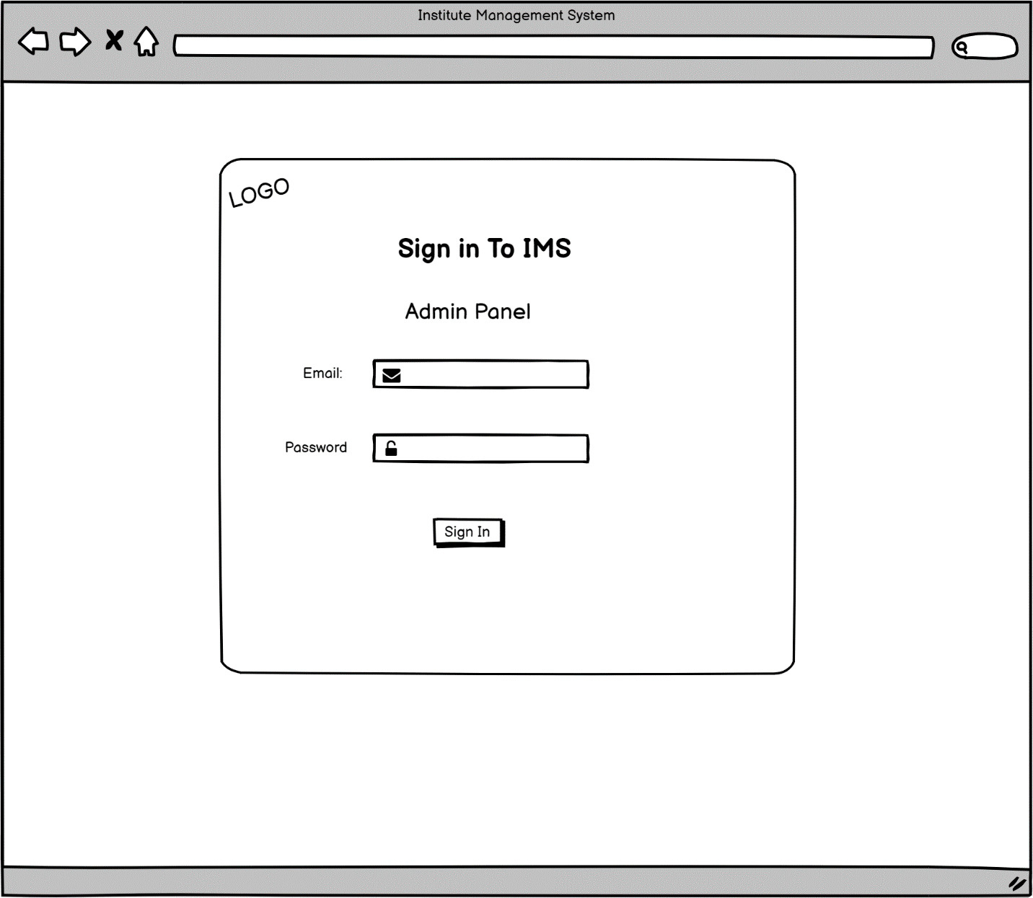

Figure 6 Admin Panel Login Page

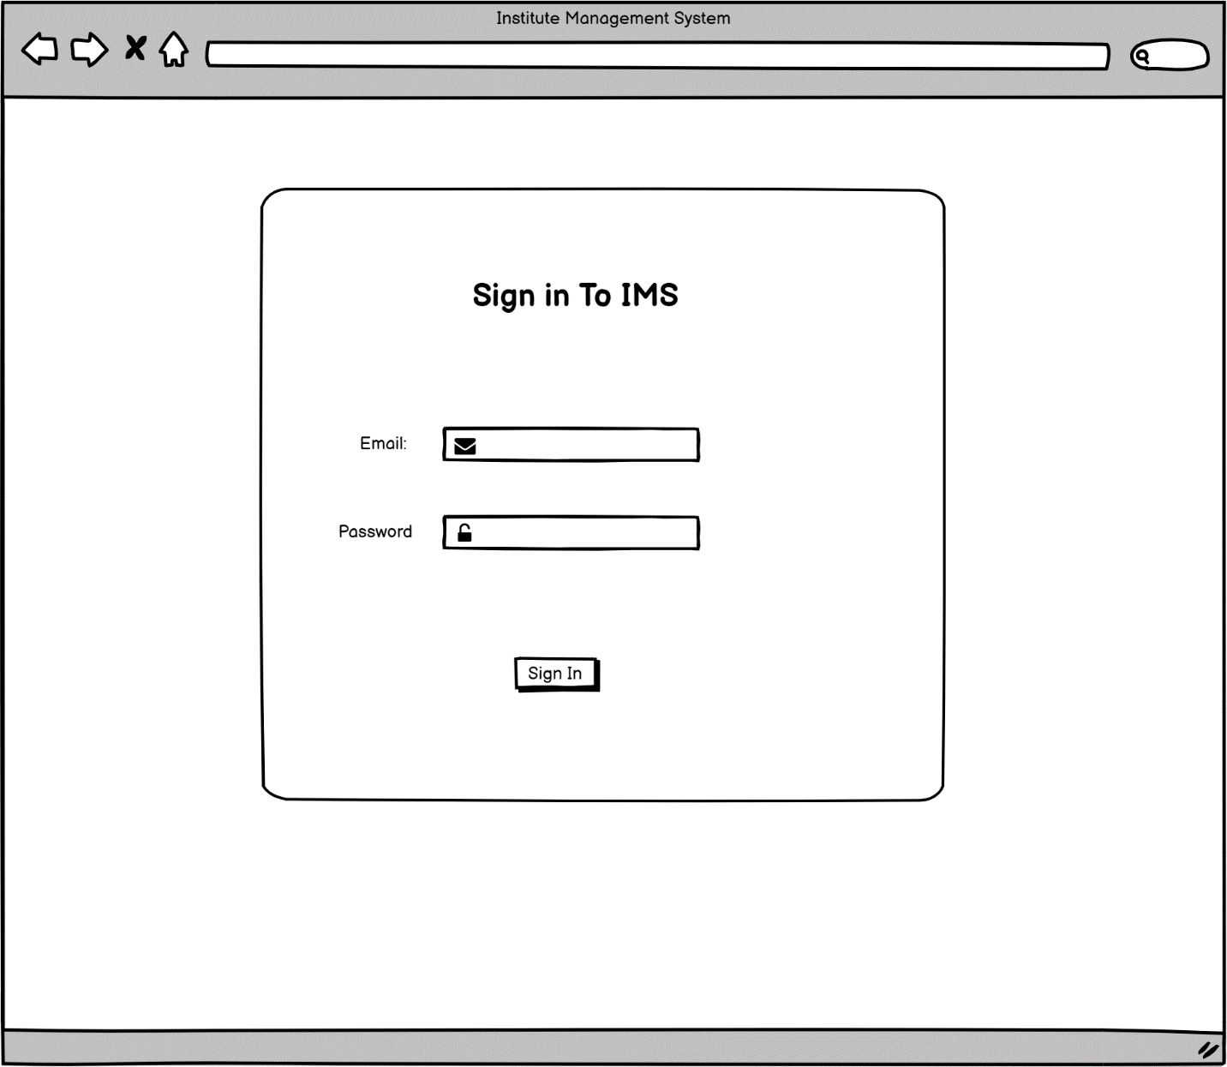

Figure 7 Login for Staff Page

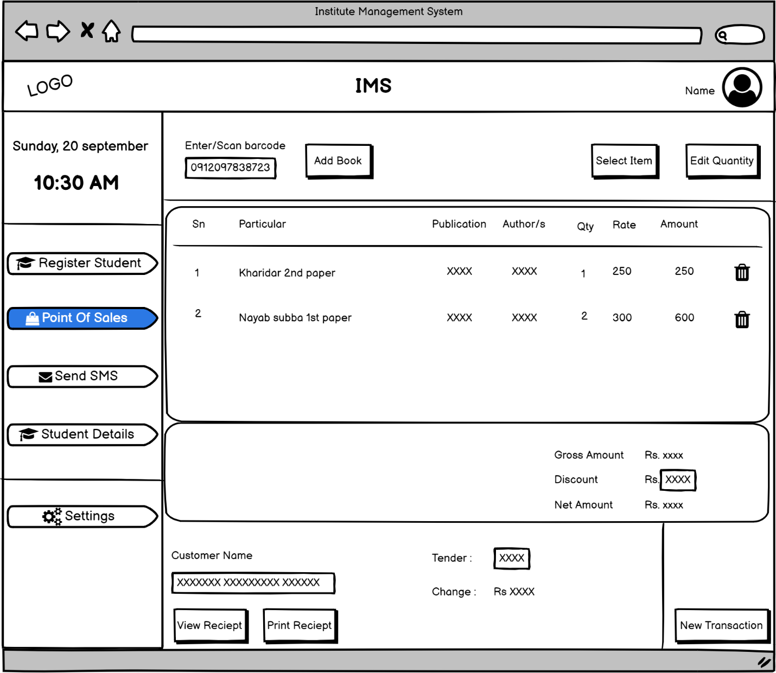

Figure 8 Point of sales / landing page of web application

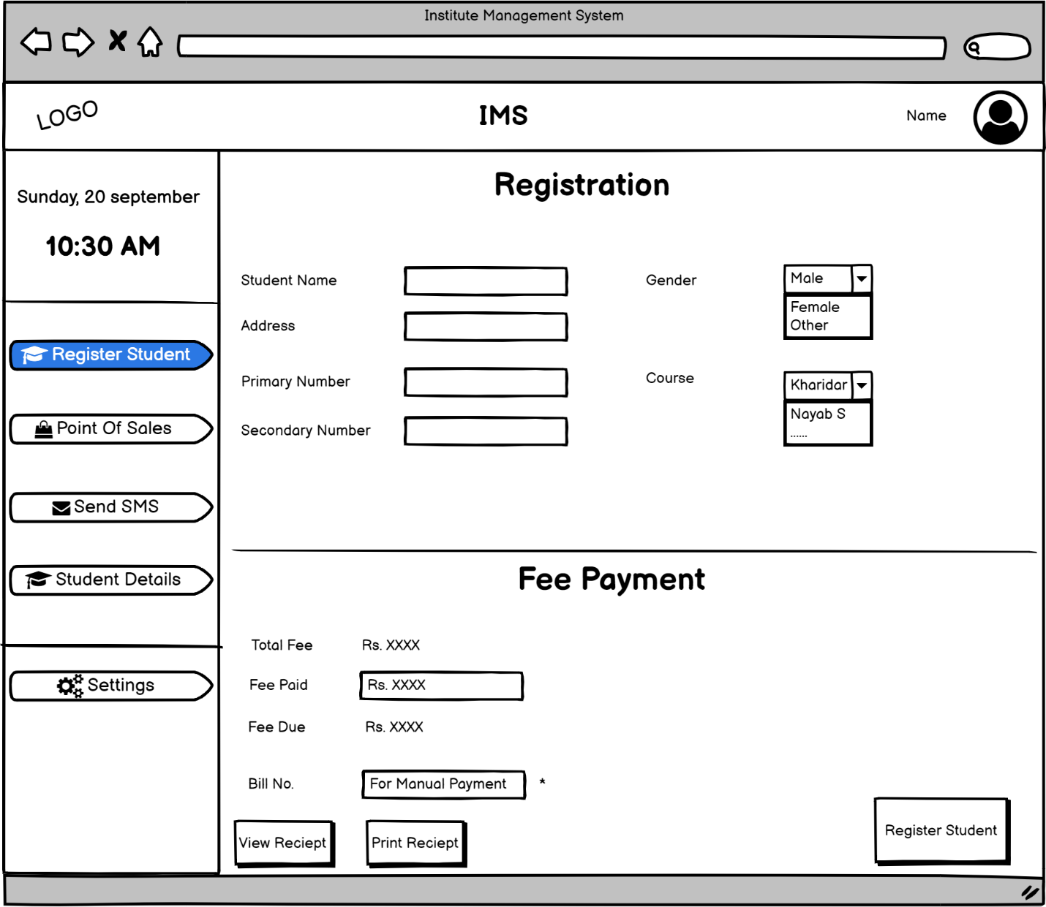

Figure 9 Student Registration page

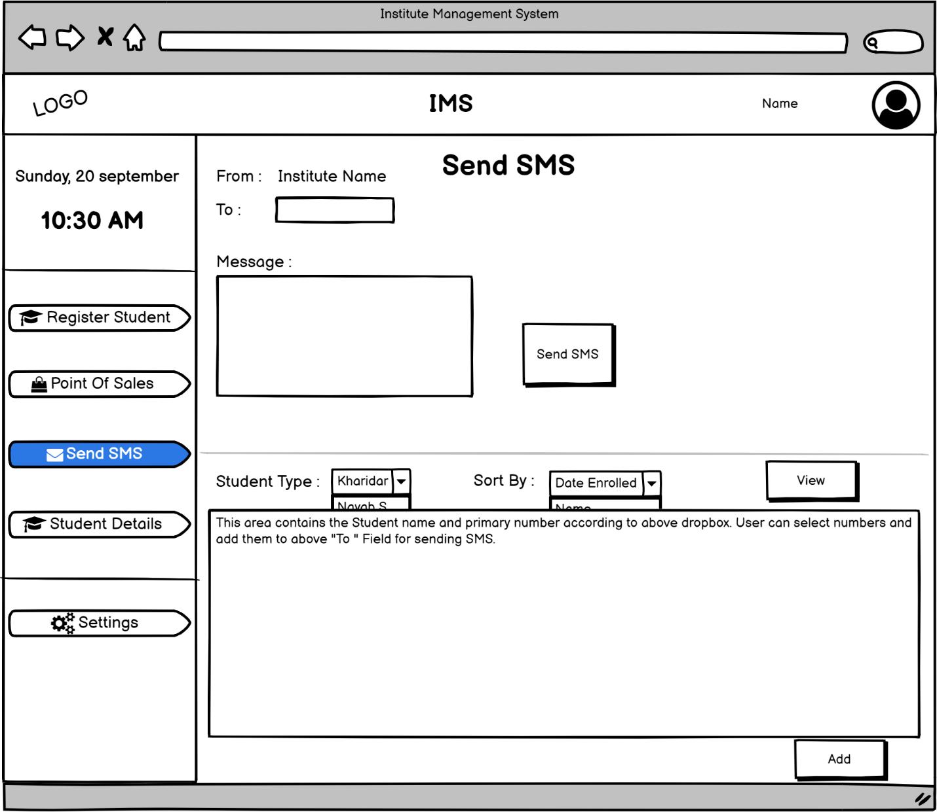

Figure 10 Send SMS page

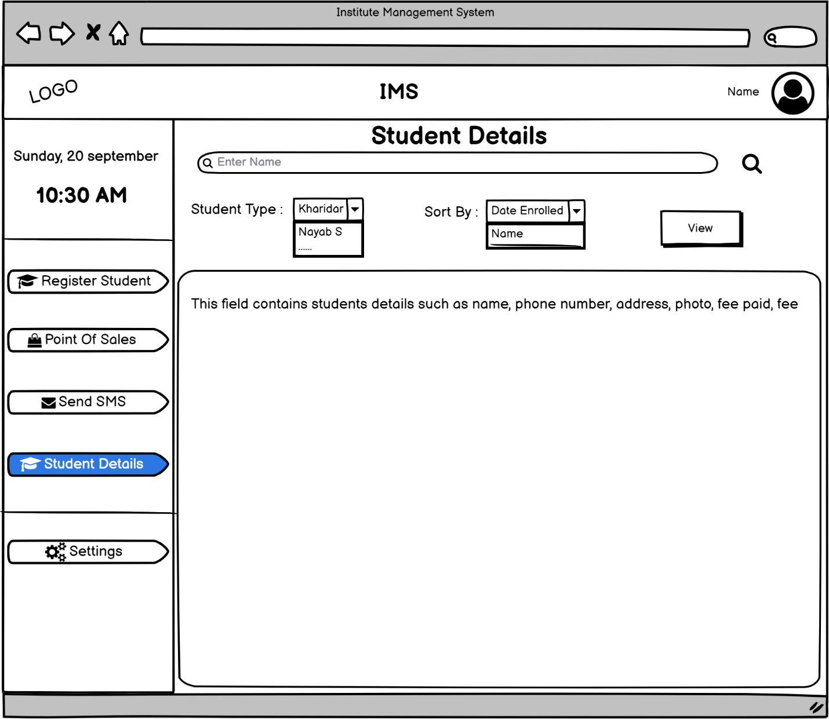

Figure 11 Student Details Page

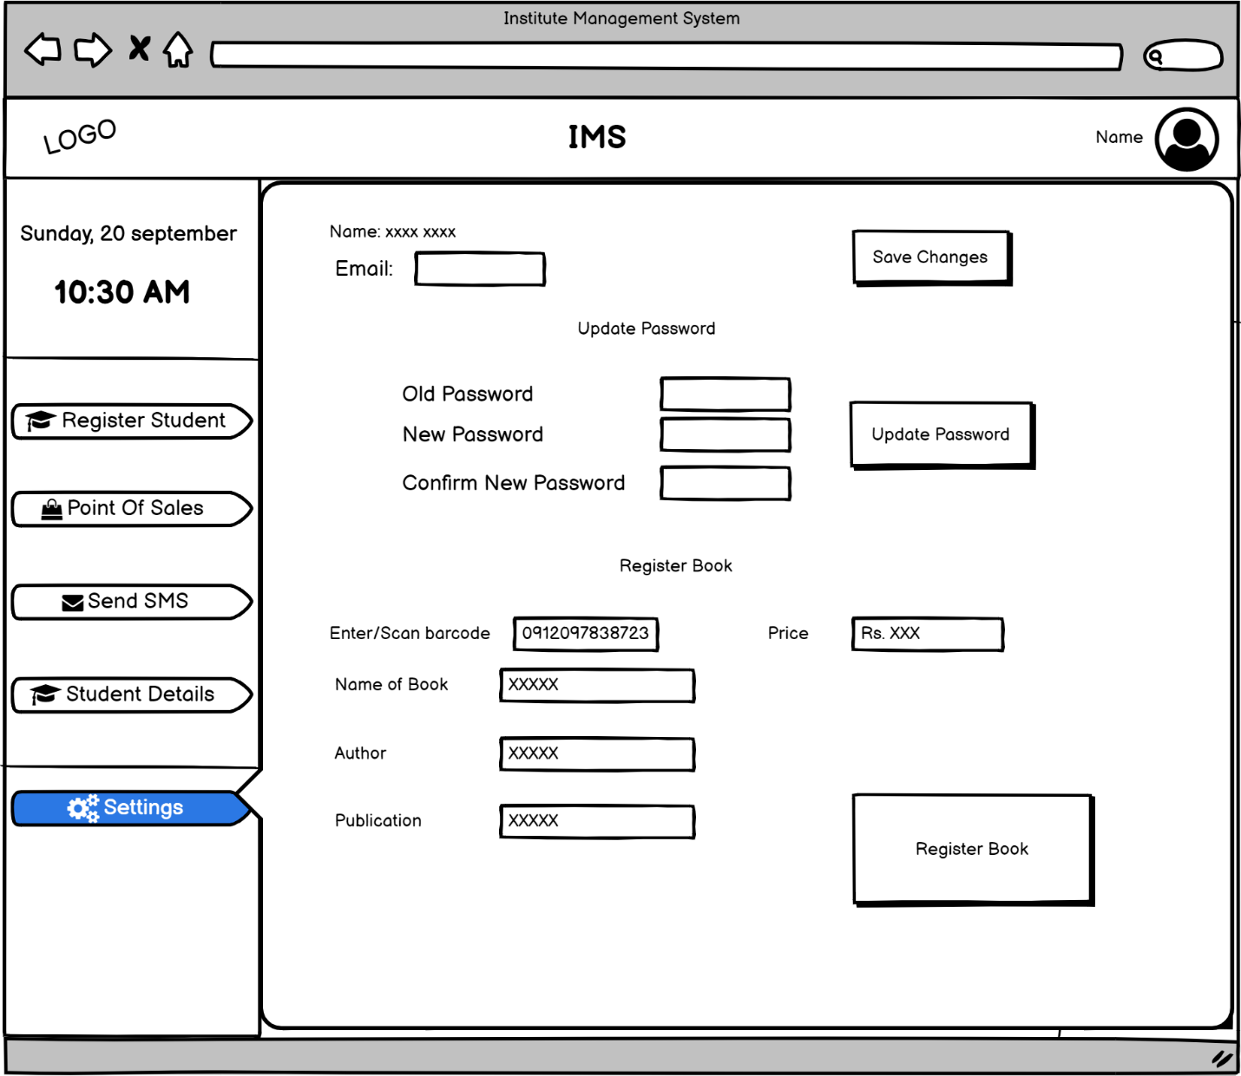

Figure 12 Account Setting / Staff Setting page

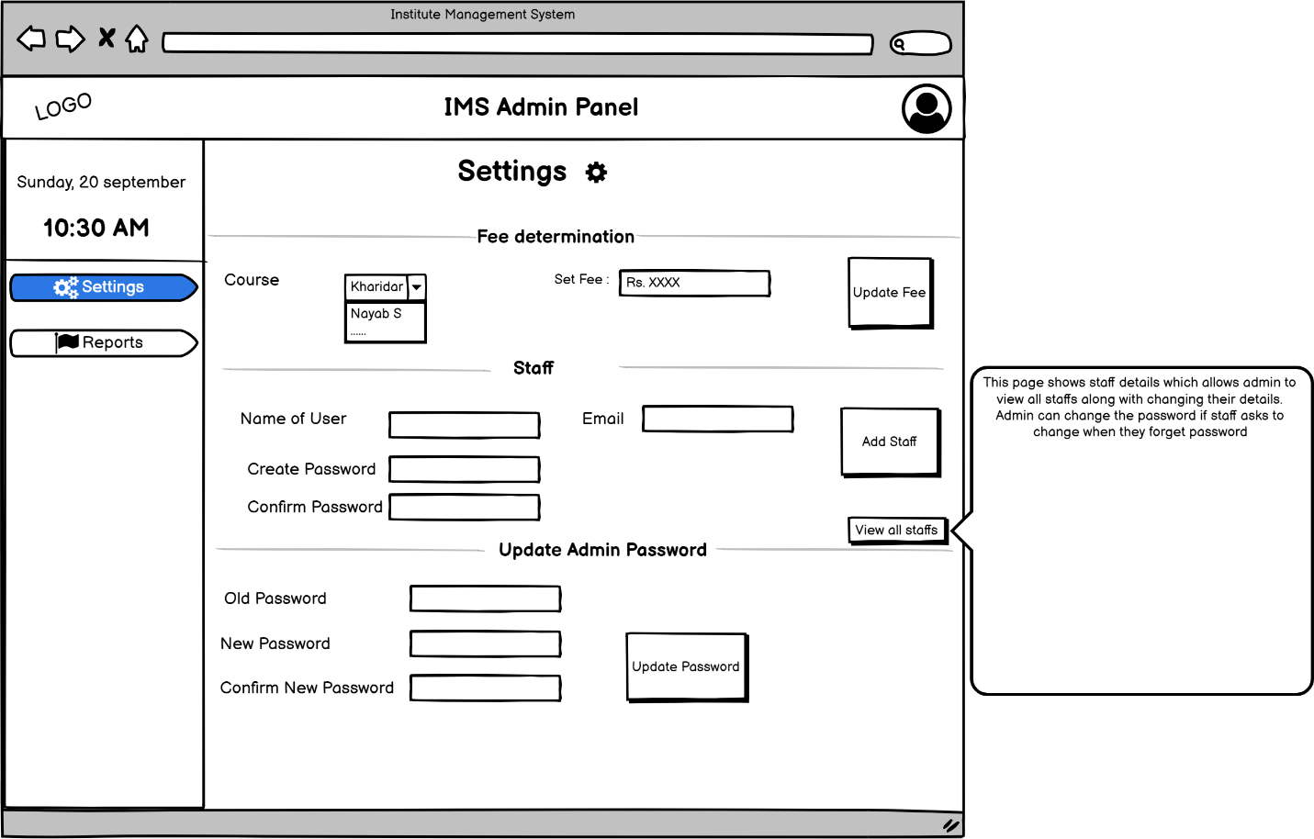

Figure 13 Admin Setting Page

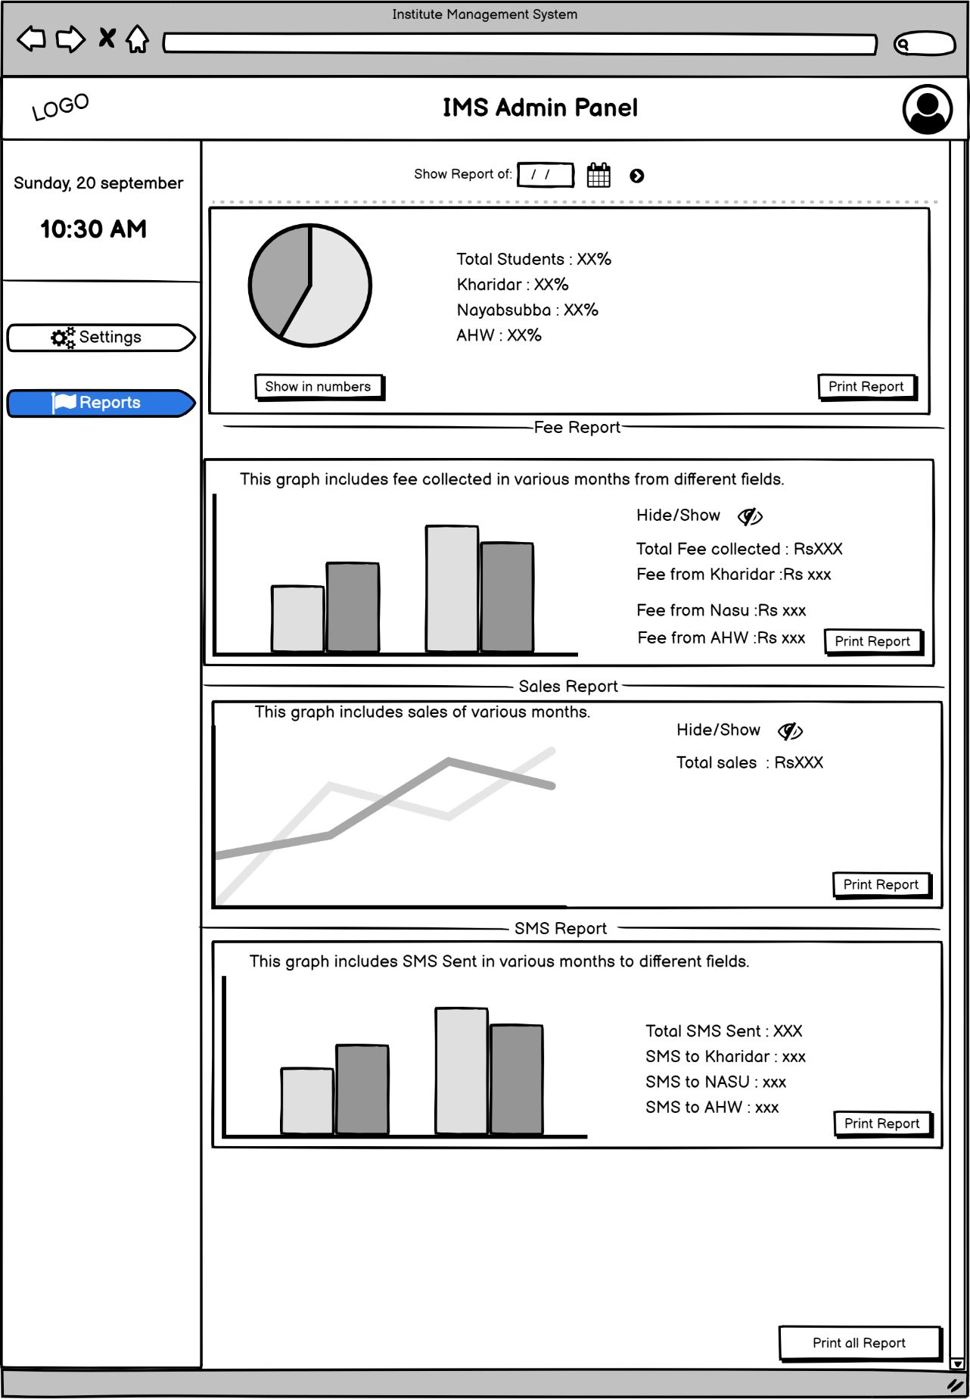

Figure 14 Report Page

## ER diagram

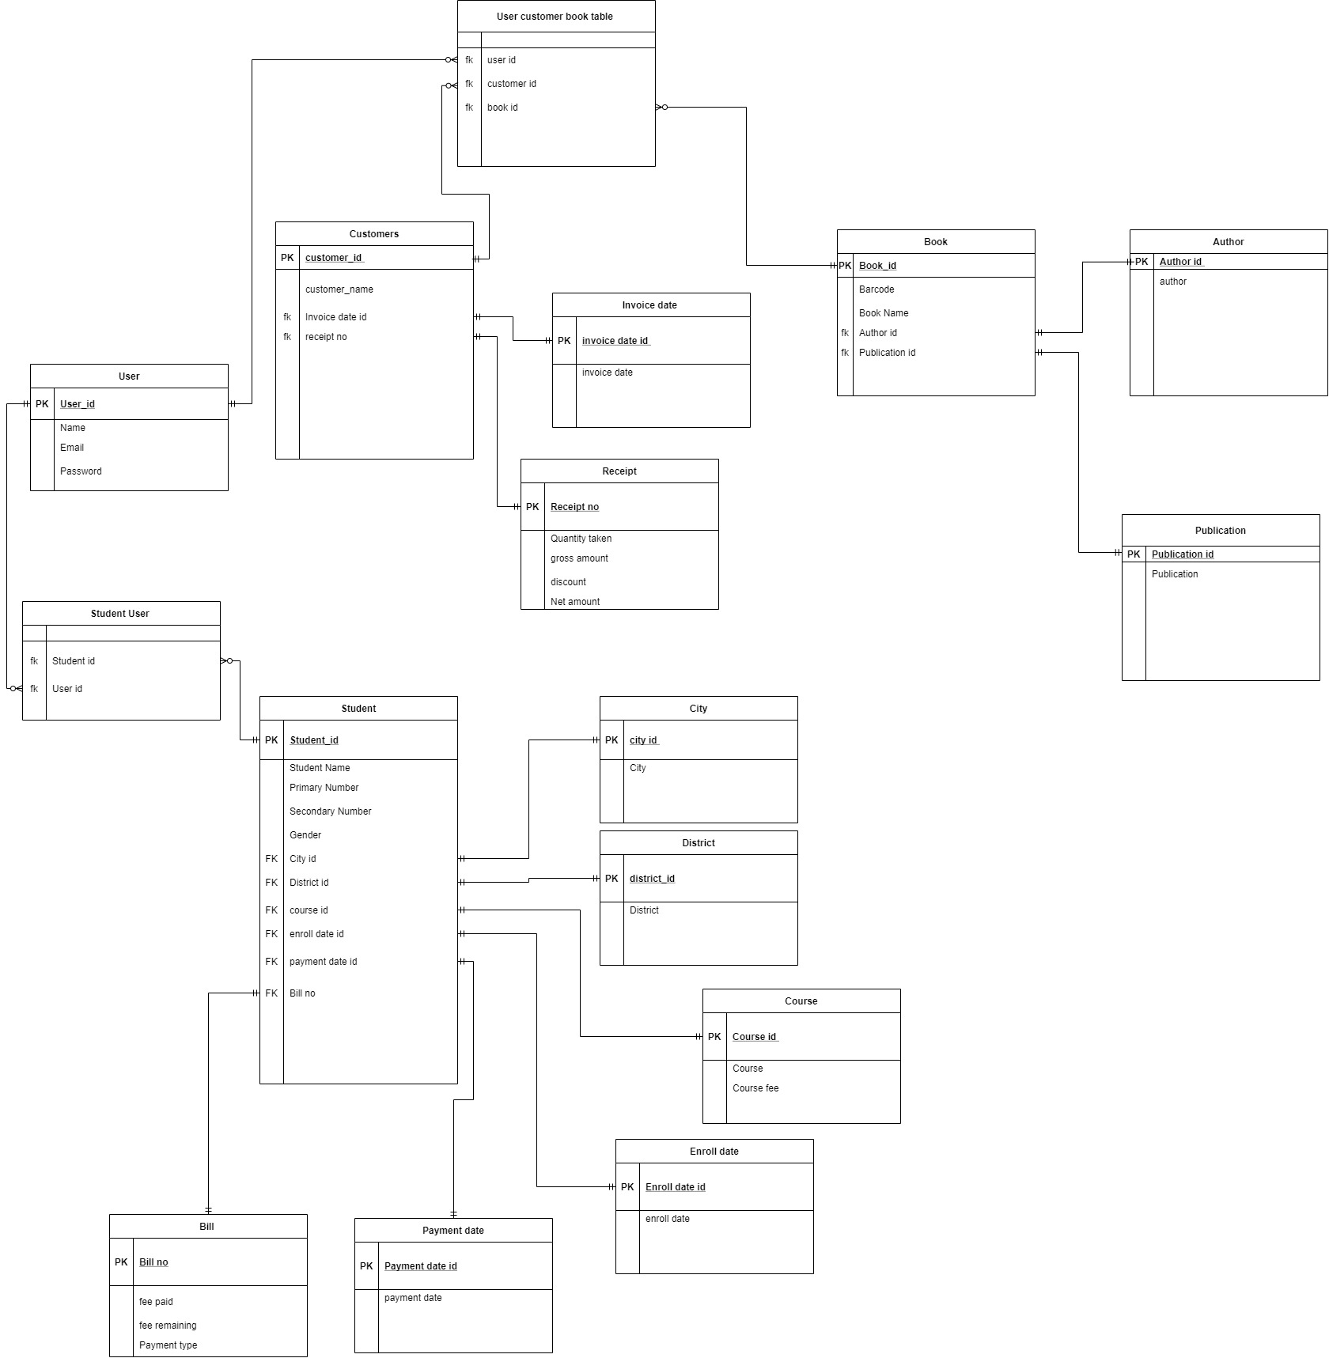

Figure 15 ER Diagram

## Web application development

### Staff Login Page

Figure 16 Staff Login Page

### Admin Login Page

Figure 17 Admin Login Page

*Please refer* *Appendix A* *for Source Code.*

## Gantt Chart

Figure 18 Gantt Chart

Tabular form of Gantt chart is provided below:

|  |  |  |  |
| --- | --- | --- | --- |
| **Activities** | **Start** | **End** | **Days** |
| **Inception** | **10/1/2020** | **11/27/2020** |  |
| Gathering Requirement | 1-Oct | 2-Nov | 32 |
| Research on Similar Projects | 7-Oct | 24-Nov | 48 |
| Develop Project Proposal | 8-Oct | 25-Nov | 48 |
| Approval Project Proposal | 26-Nov | 27-Nov | 1 |
|  |  |  |  |
| **Elaboration** | **11/1/2020** | **1/10/2021** |  |
| Wireframe Development | 3-Nov | 7-Jan | 65 |
| Use case Diagram Development | 3-Nov | 10-Jan | 68 |
| System Architecture Development | 8-Nov | 2-Dec | 24 |
| Planning on Design | 1-Nov | 05-Jan | 65 |
| Review Project To supervisor | 1-Dec | 24-Dec | 23 |
|  |  |  |  |
| **Construction** | **10/18/2020** | **4/9/2021** |  |
| Completing Coding Part | 18-Oct | 26-Mar | 159 |
| User Manual | 8-Nov | 21-Jan | 74 |
| Test And Review to Supervisor | 17-Jan | 9-Apr | 82 |
|  |  |  |  |
| **Transition** | **11/22/2020** | **4/16/2021** |  |
| Ask for Feedback and Make changes | 22-Nov | 4-Mar | 102 |
| Proper Documentation | 29-Nov | 14-Apr | 136 |
| Finalizing Project | 7-Jan | 16-Apr | 99 |

Table 15 Gantt chart

# Analysis of progress

## 4.1. Progress table

|  |  |  |  |
| --- | --- | --- | --- |
| **S.N.** | **Tasks** | **Status** | **Progress(%)** |
| 1 | Gathering Requirement | Completed | 100 |
| 2 | Research on Similar Projects | Completed | 100 |
| 3 | Develop Project Proposal | Completed | 100 |
| 4 | Approval Project Proposal | Completed | 100 |
| 5 | Wireframe Development | Almost completed | 90 |
| 6 | Use case Diagram Development | Almost completed | 80 |
| 7 | System Architecture Development | Completed | 100 |
| 8 | Planning on Design | Almost completed | 90 |
| 9 | Review Project To supervisor | Completed | 100 |
| 10 | Completing Coding Part | Initialized | 10 |
| 11 | User Manual | Incomplete | 0 |
| 12 | Test and Review to Supervisor | Incomplete | 0 |
| 13 | Ask for Feedback and Make changes | Incomplete | 0 |
| 14 | Proper Documentation | Initialized | 5 |
| 15 | Finalizing Project | Incomplete | 0 |

Table 16 Progress Table

*Please refer to* *Appendix B* *for Milestone Review*

## 4.2. Progress Review and Action Plan

As in above progress table, requirement gathering, research on similar projects, proposal development, system architecture development is completed in time as planned in Gantt chart submitted in project proposal. Design part such as wireframe development, use case development, planning on design are delayed but almost completed. Things that didn’t go as per plan is coding part. Coding part is not completed as it should be because of spending little more time in wireframe and use case development.

From now onwards, tasks will be carried out according to new Gantt chart which is submitted in interim report. Coding part will be given more priority as other tasks are going according to plan.

# Future work

This part of report includes remaining tasks that are to be completed in future time. As per Gantt chart following things are future tasks:

1. Finalizing Wireframe Development
2. Completing Use case development and design planning
3. Preparation of User Manual
4. Working on barcode system
5. Working on SMS API integration
6. Completing Coding part
7. Finalizing documentation
8. Submission of Final year Project Report

# References

ANWAR, A., 2014. A Review of RUP (Rational Unified Process). *International Journal of Software Engineering (IJSE),* 5(2), p. 13.

Christensson, P., 2006. *techterms.* [Online]   
Available at: https://techterms.com/definition/rup  
[Accessed 14 october 2020].

Kruchten, P., 2004. *The Rational Unified Process: An Introduction.* 3rd ed. s.l.:Addison-Wesley Professional.

K, S., Samanekar, A. & Pujar, N. T., 2018. Student Management System. *INTERNATIONAL JOURNAL OF ENGINEERING RESEARCH & TECHNOLOGY,* VI(15), pp. 1-4.

Ros, F., 2019. *code-projects..* [Online]   
Available at: https://code-projects.org/student-record-management-system-in-php-with-source-code/  
[Accessed 23 12 2020].

S.Balaji & Murugaiyan, D., 2012. WATEERFALLVs V-MODEL Vs AGILE: A COMPARATIVE STUDY ON SDLC. *International Journal of Information Technology and Business Management,* II(1), pp. 26-30.

S.R.Bharamagoudar, R.B., G. & S.G.Totad, 2013. Web Based Student Information Management. *International Journal of Advanced Research in Computer and Communication Engineering,* II(6), pp. 2342-2348.

Scott, K., 2001. *informit.* [Online]   
Available at: https://www.informit.com/articles/article.aspx?p=24671&seqNum=7  
[Accessed 14 october 2020].

t4tutorials, 2020. *t4tutorials.* [Online]   
Available at: https://t4tutorials.com/rational-unified-process-rup-phases-of-rup-inception-elaboration-construction-transition-software-engineering/#What_is_the_elaboration_phase  
[Accessed 14 october 2020].

# Appendix A

StaffLogin.blade.php

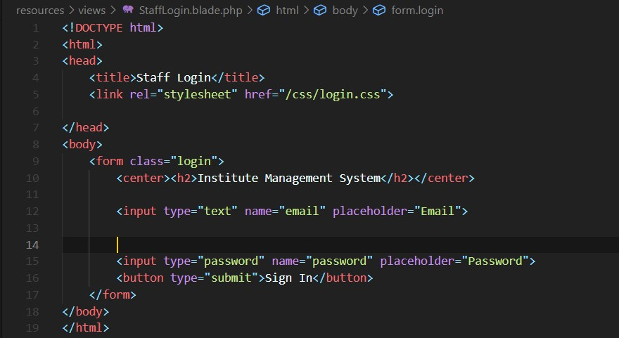

Figure 19 Staff Login Source Code

AdminLogin.blade.php

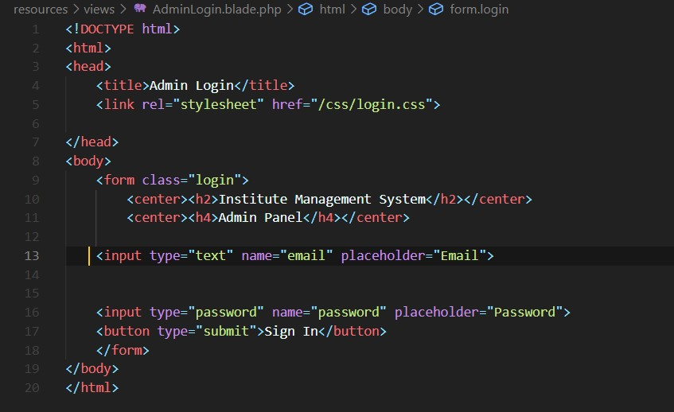

Figure 20 Admin Login Source Code

# Appendix B

Milestone review is provided below:

* **Milestone 1:** Proposal Submission

**Status:** Completed

* **Milestone 2:** Interim Report Submission

**Status:** Only Submission remaining

* **Milestone 3:** UI design and wireframe

**Status:** Almost Completed

* **Milestone 4:** Develop Use Case

**Status:** Almost Completed

* **Milestone 5:** Development of Web application

**Status:** Initialized

* **Milestone 6:** Testing

**Status:** Incomplete

* **Milestone 7:** Documentation

**Status:** Incomplete

* **Milestone 8:** Submit final Year project

**Status:** Incomplete

# Appendix C

Survey Findings

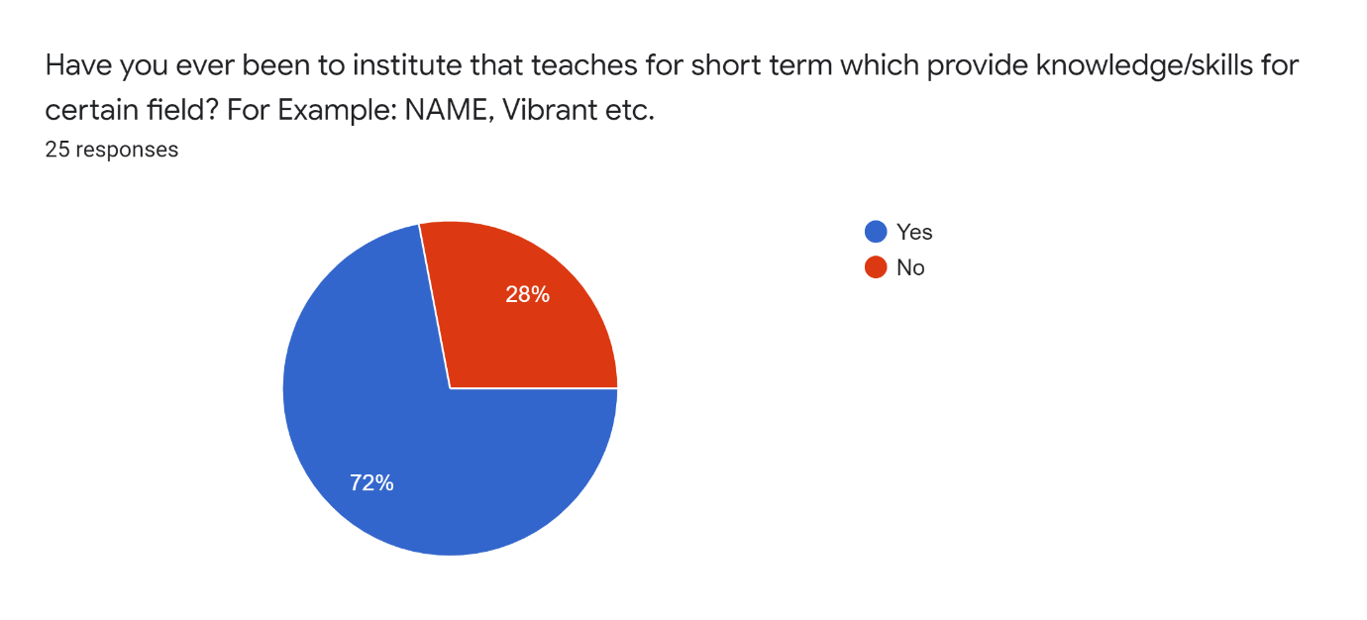

Figure 21 Survey Question 1

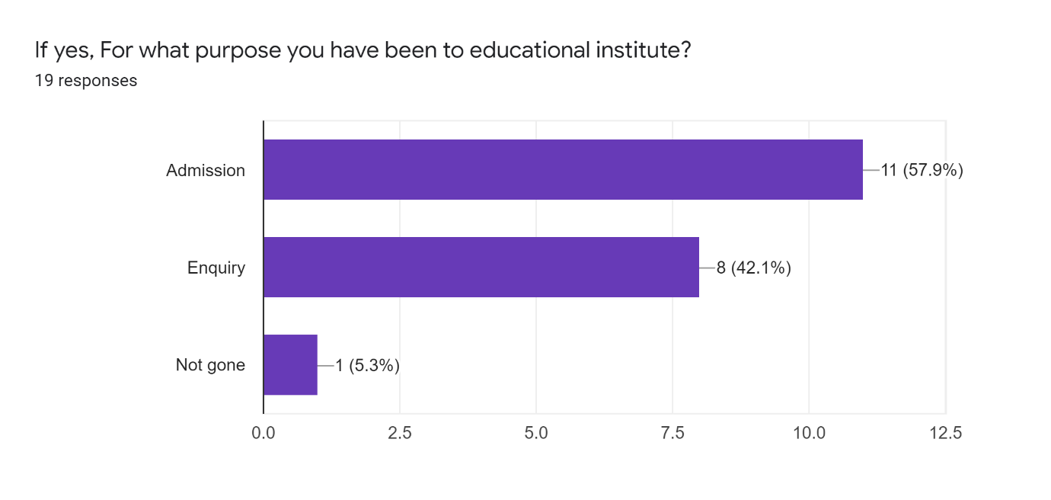

Figure 22 Survey Question 2

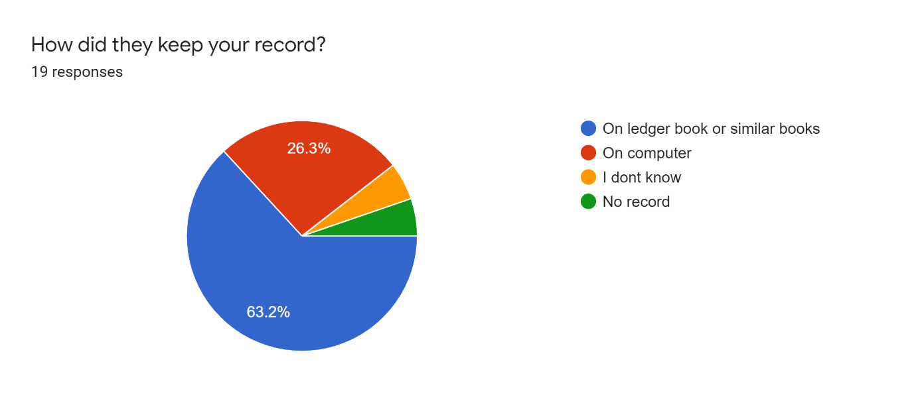

Figure 23 Survey Question 3

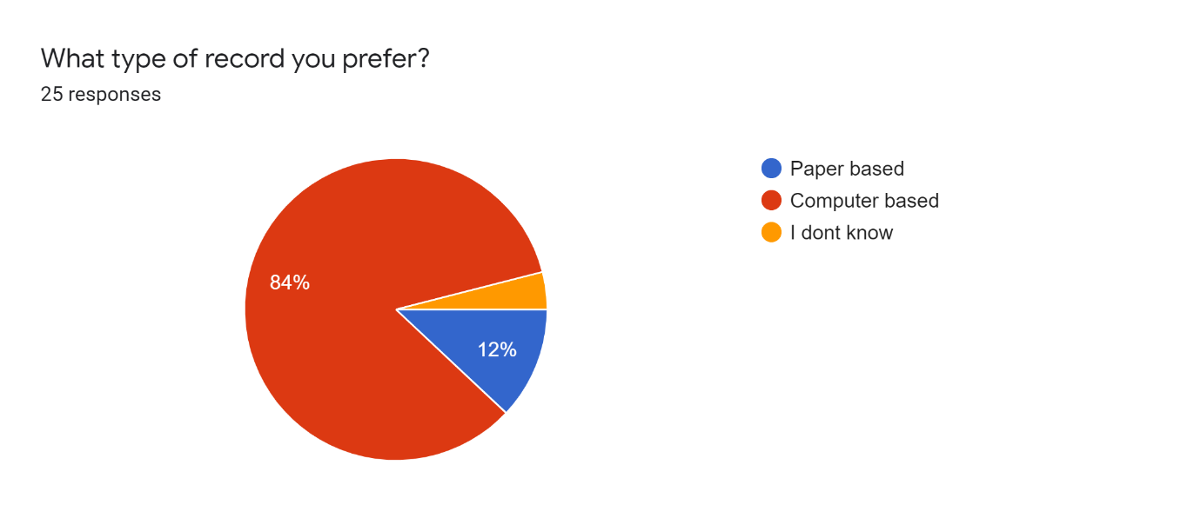

Figure 24 Survey Question 4

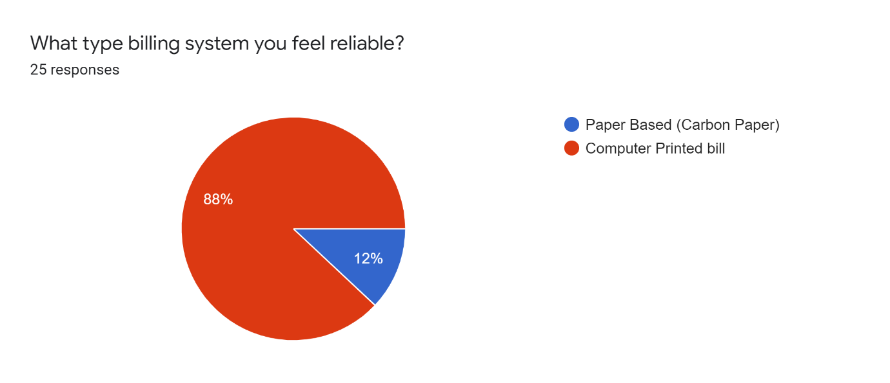

Figure 25 Survey Question 5

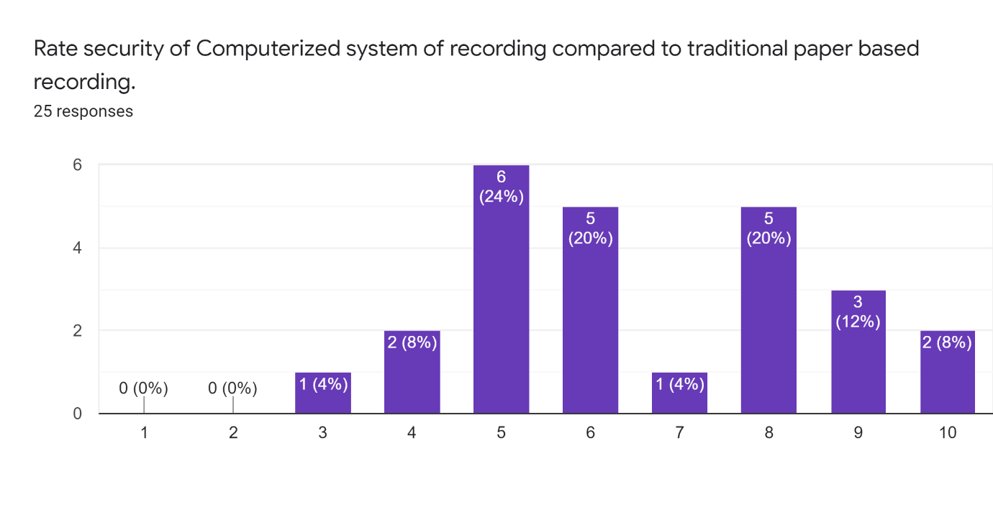

Figure 26 Survey Question 6

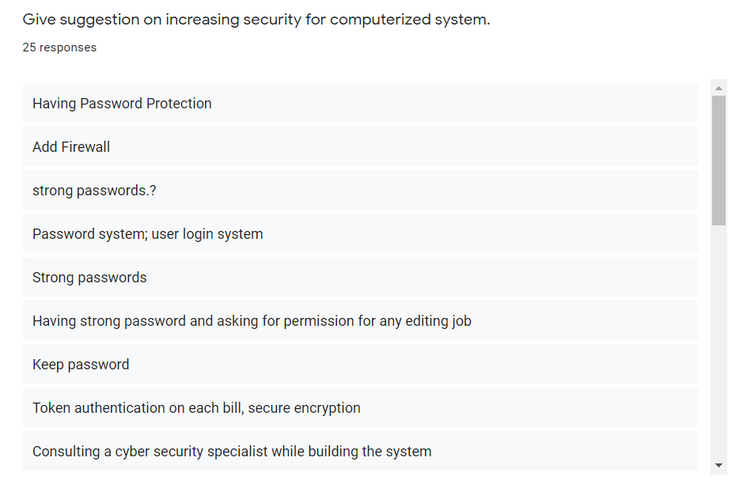 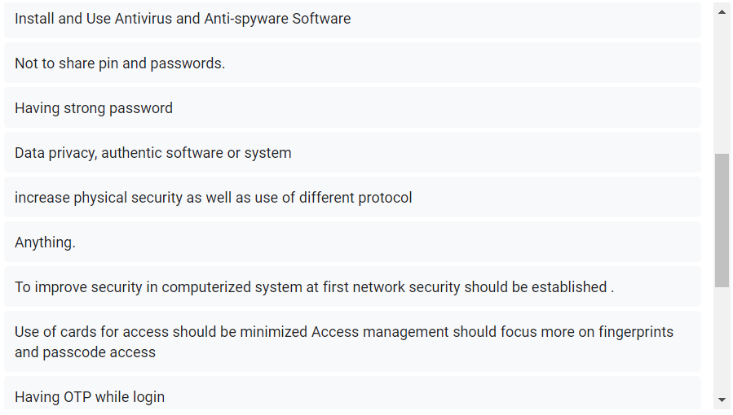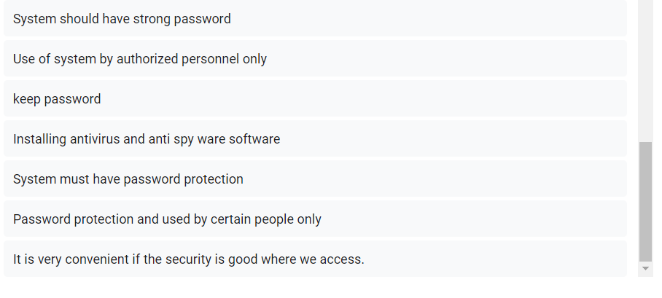

Figure 27 Survey Question 7

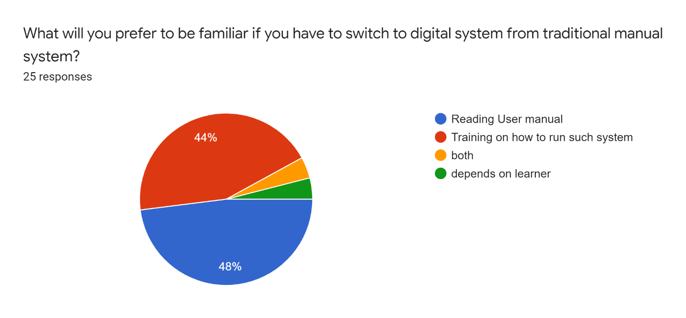

Figure 28 Survey Question 8